AI ASSISTED CODING
LAB-12.4
NAME: MOHAMMED AREEBUDDIN
ENROLLNO:2403A52054
BATCH:03
TASK-01:
Implementing Bubble Sort with AI Comments.
PROMPT:
Generate a python code to implement bubble sort.
CODE:
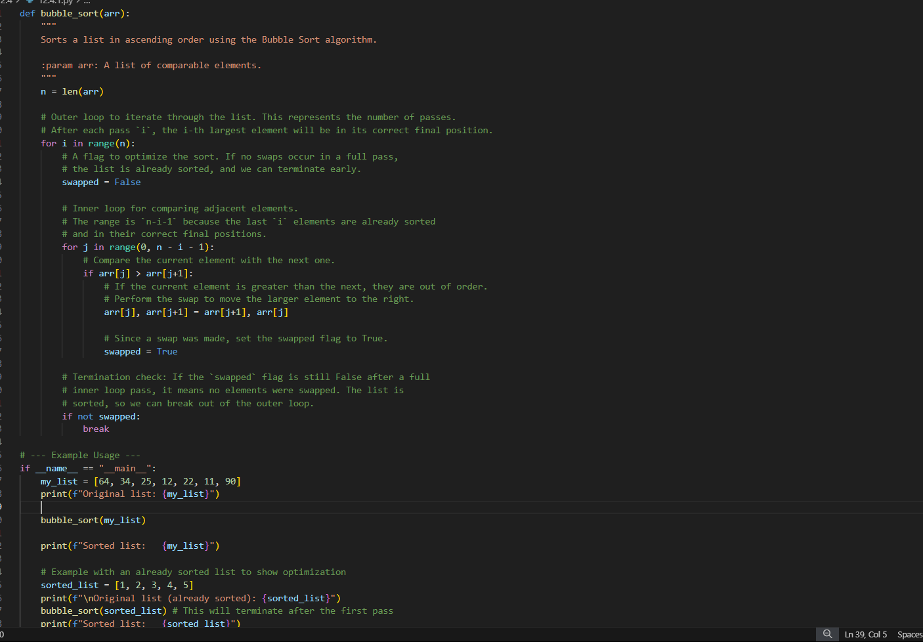
OUTPUT:
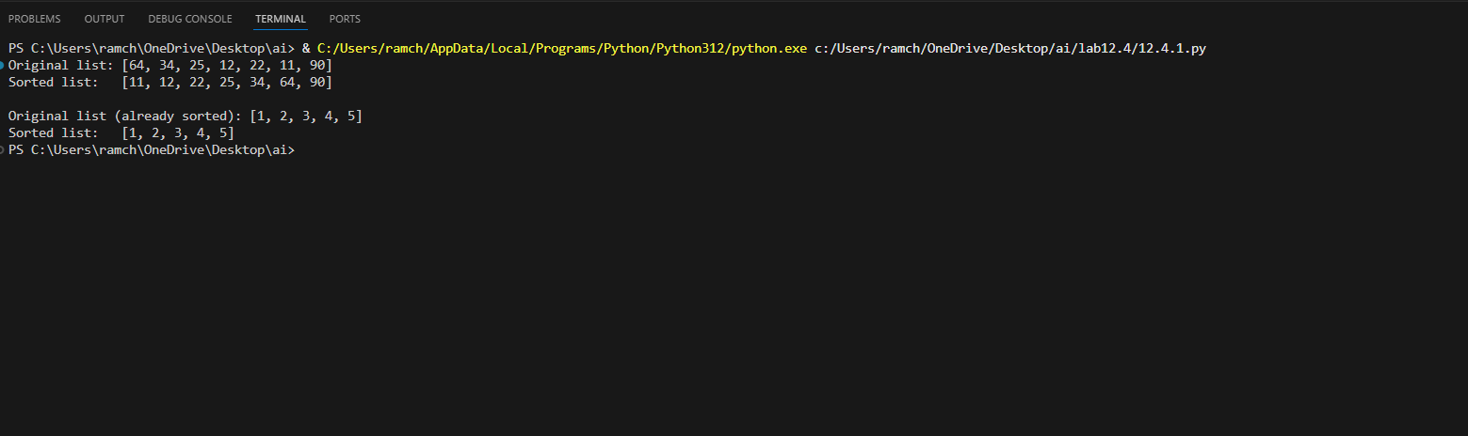
OBSERVATION:
Bubble Sort repeatedly compares and swaps adjacent elements if they are in the wrong order, moving the largest element to the end in each pass — like bubbles rising to the top.
TASK-02:
Optimizing Bubble Sort → Insertion Sort
PROMPT:
Convert the following bubble sort code to the insertion sort.
CODE:
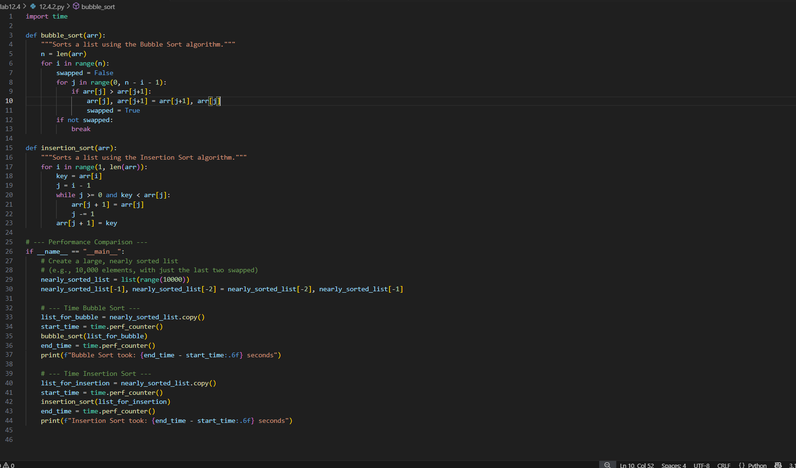
OUTPUT:
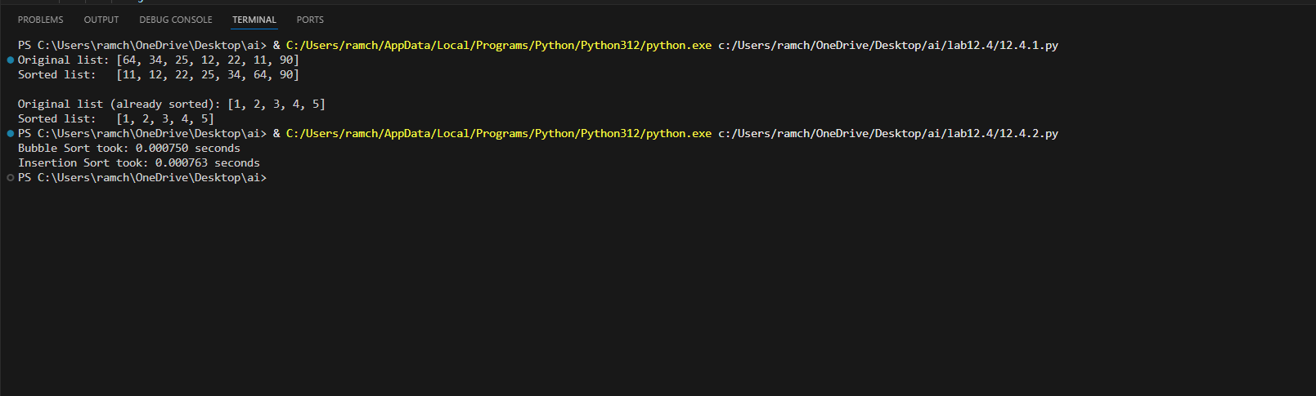
OBSERVATION:
Optimization from Bubble Sort to Insertion Sort:
Instead of repeatedly swapping adjacent elements like in Bubble Sort, Insertion Sort shifts elements to insert each item directly into its correct position. This reduces unnecessary swaps and makes it faster, especially for nearly sorted data.
TASK-03:
Binary Search vs Linear Search
PROMPT:
Implement the linear search and binary search with comments.
CODE:
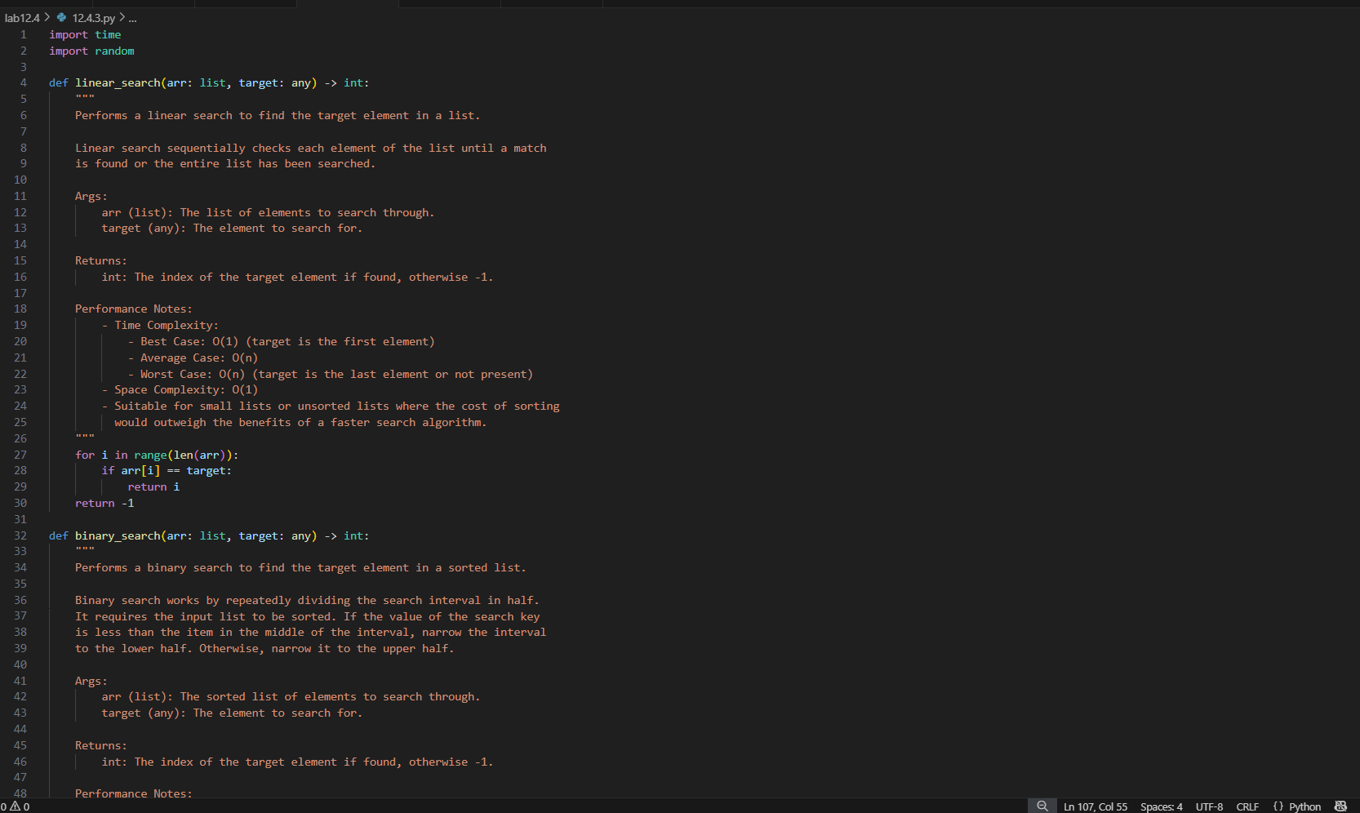
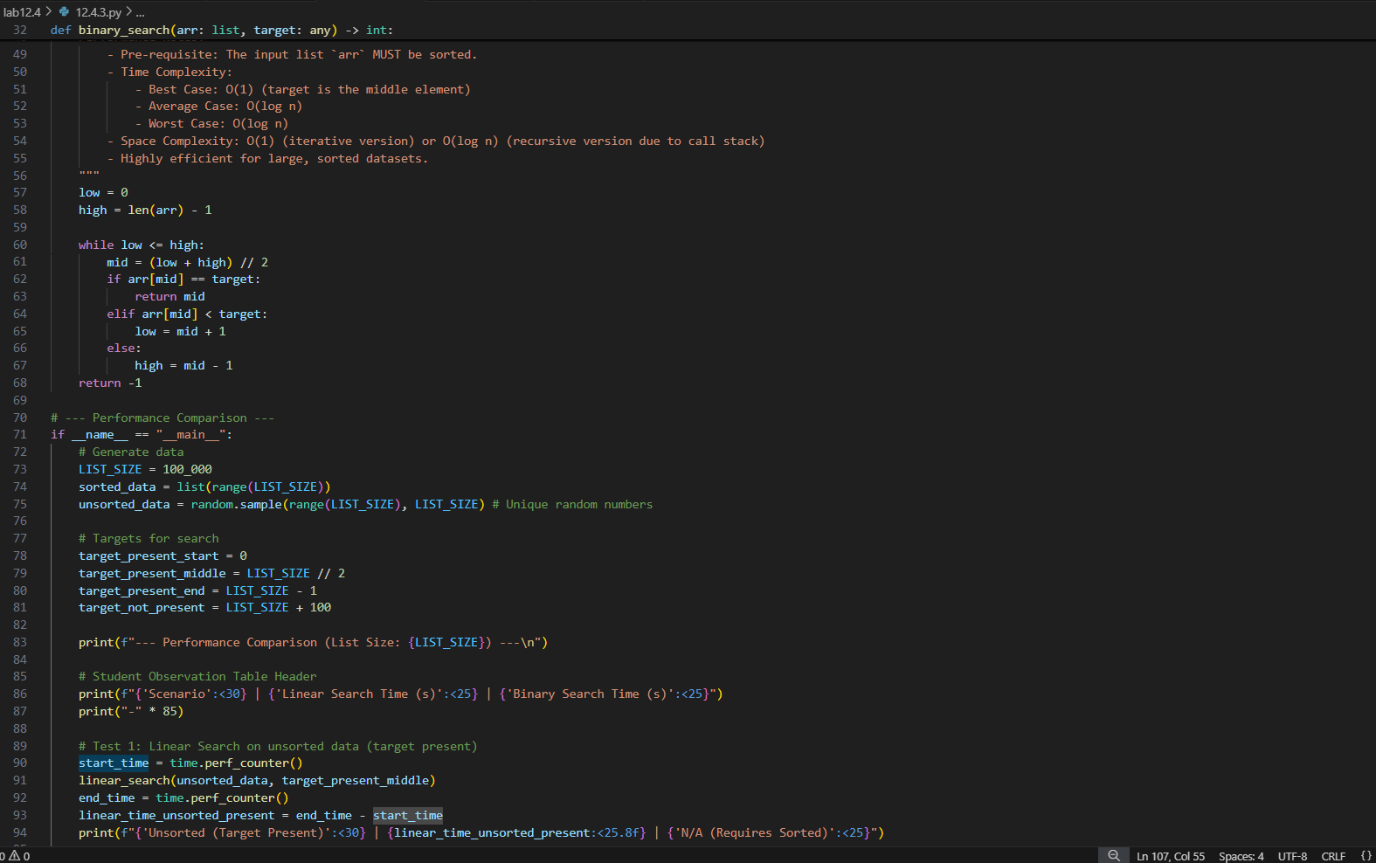
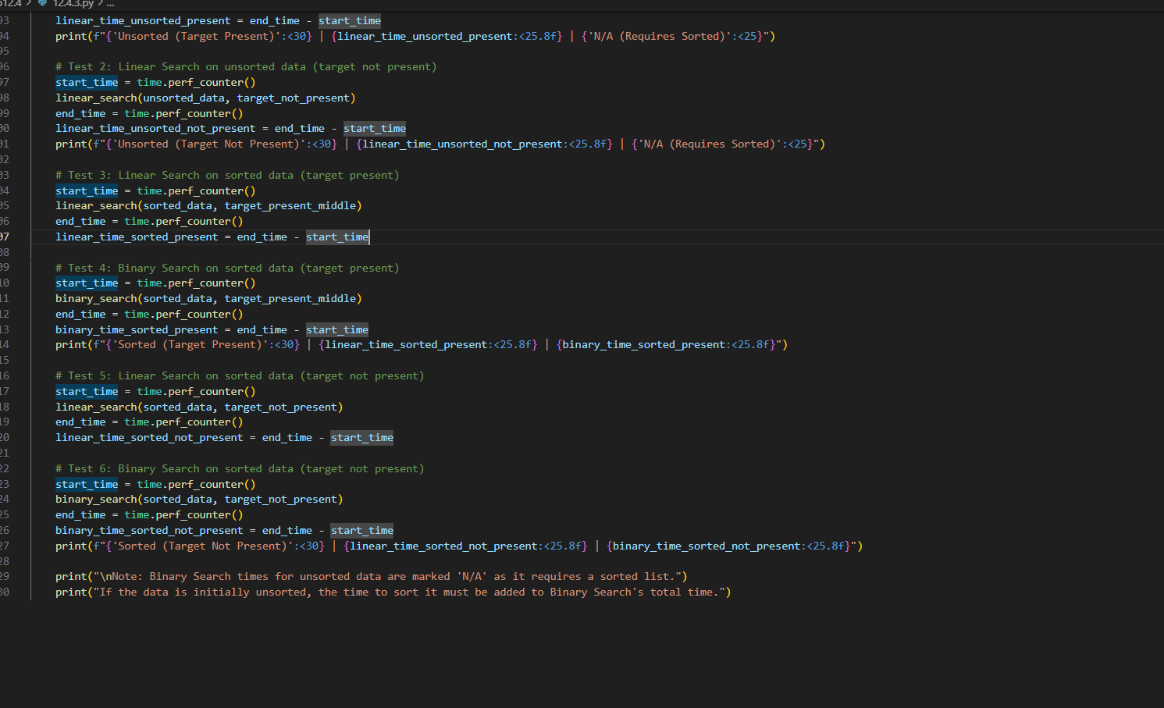
OUTPUT:
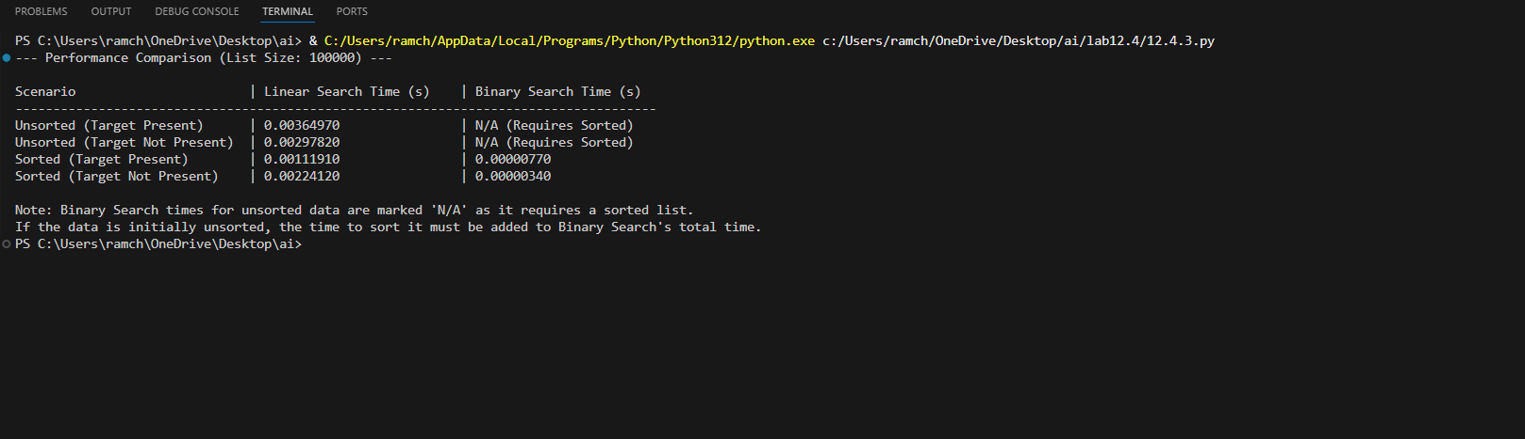
OBSERVATION:
Linear Search: Checks each element one by one until the target is found or the list ends. Works on unsorted data but is slow (O(n)).
Binary Search: Repeatedly divides a sorted list in half to find the target. Much faster (O(log n)), but requires the data to be sorted.
TASK-04:
Quick Sort and Merge Sort Comparison
PROMPT:
Implement the quick sort and merge sort using recursion.
CODE:
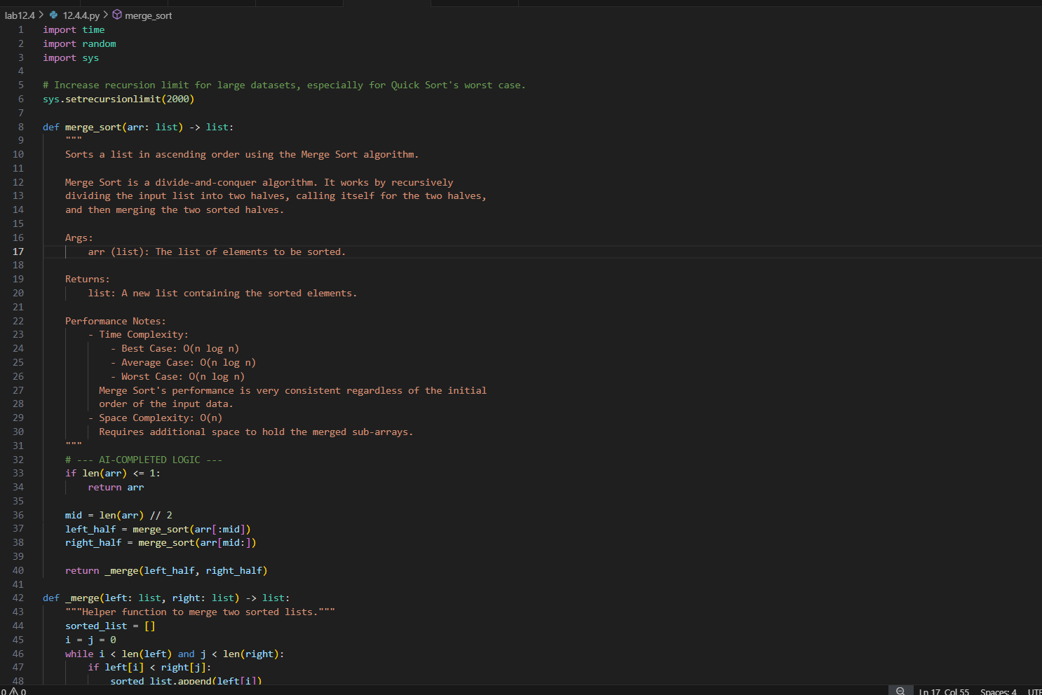
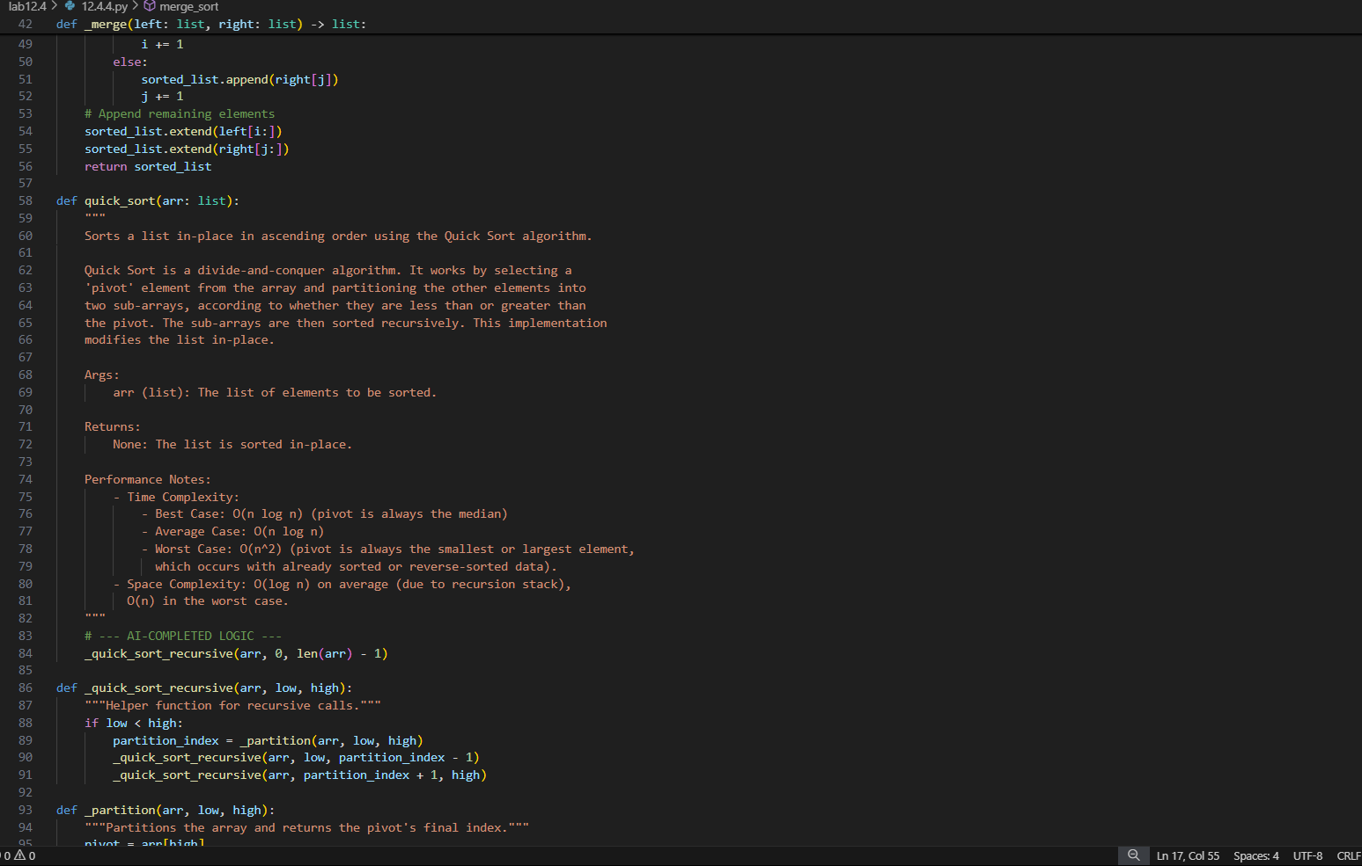
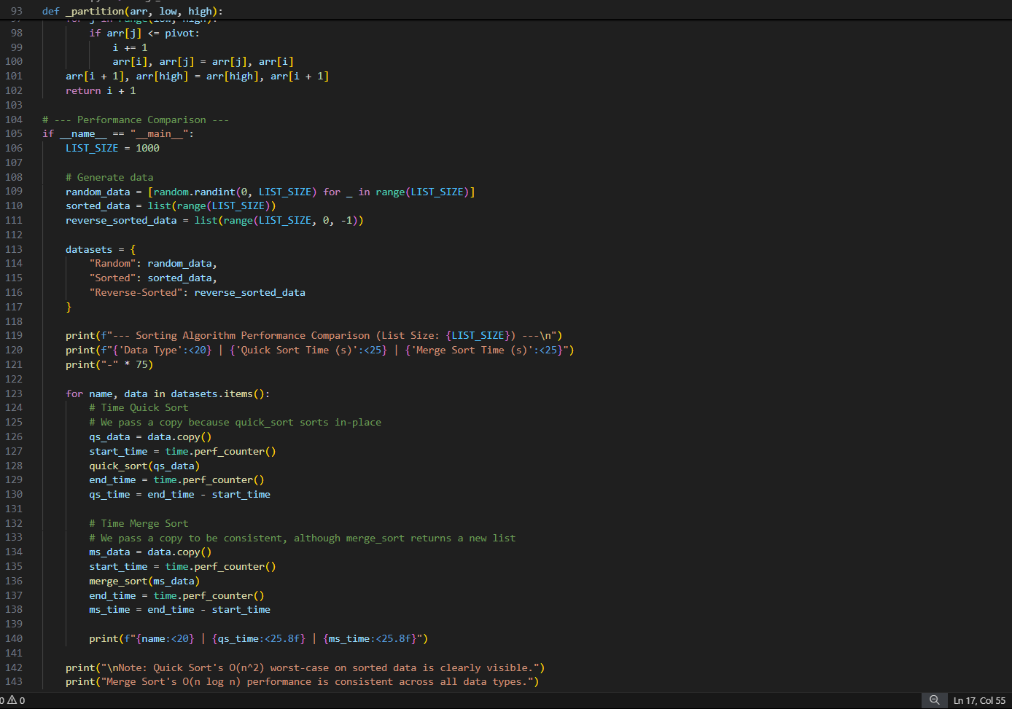
OUTPUT:
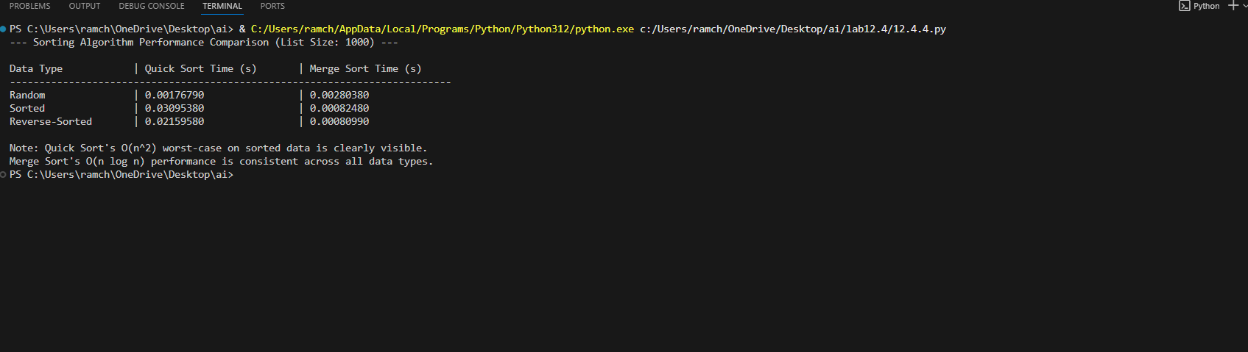
OBSERVATION:
Quick Sort: Uses a pivot to partition the array into smaller and larger elements, then sorts each part recursively. It’s faster on average (O(n log n)) but may degrade to O(n²) in the worst case.
Merge Sort: Divides the array into halves, sorts them, and then merges them. It always runs in O(n log n) time but uses extra memory for merging.
TASK-05:
AI-Suggested Algorithm Optimization
PROMPT:
Generate the python code which implements the duplicate search.
CODE:
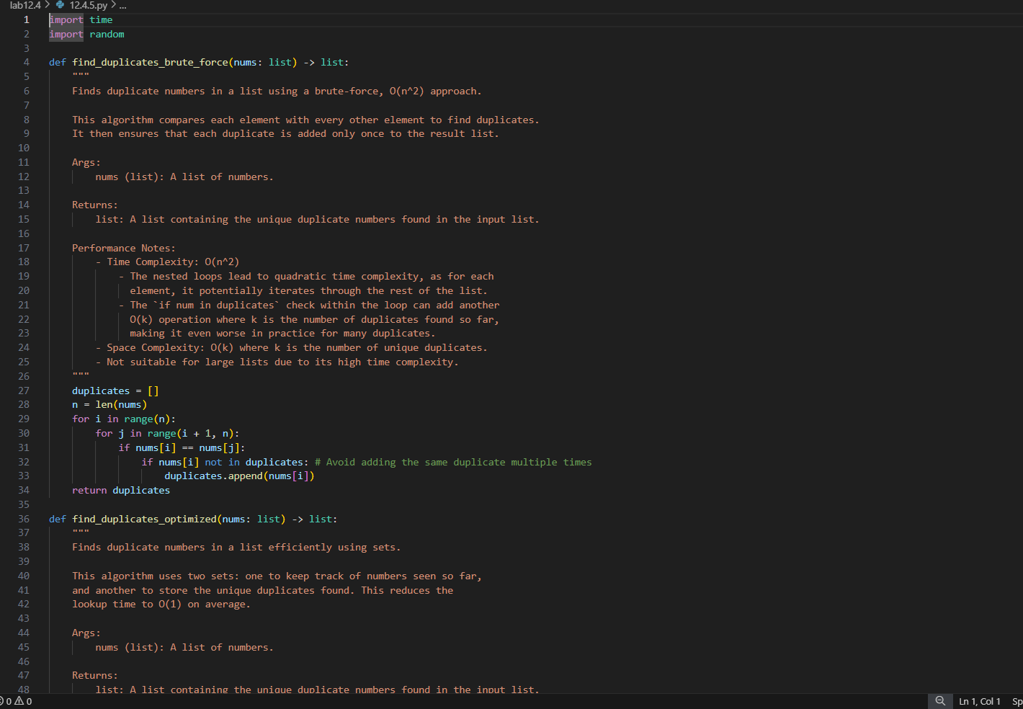
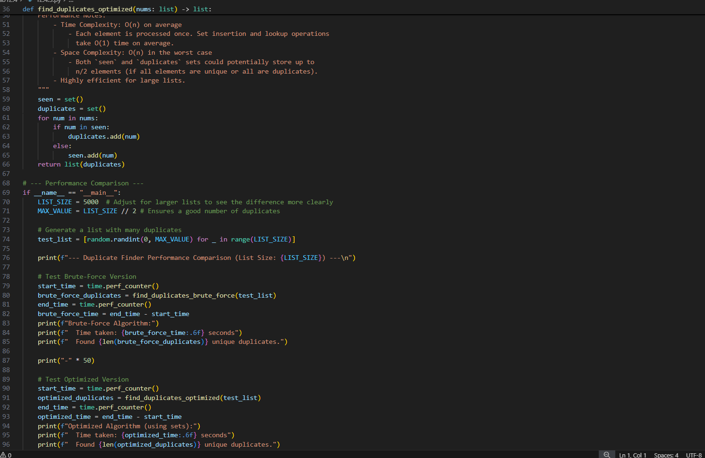
OUTPUT:
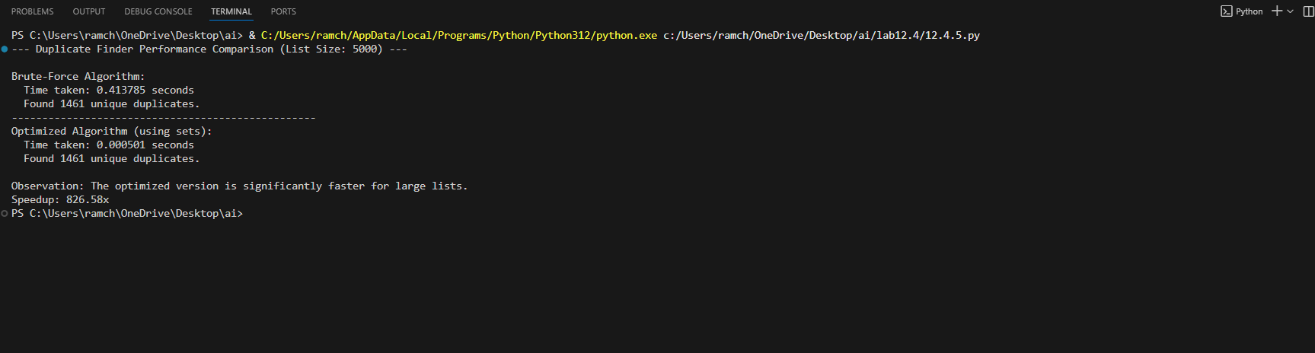
OBSERVATION:
The task involves first writing a naive duplicate-finding algorithm using nested loops, which has O(n²) complexity. Then, AI can optimize it by using a set or dictionary to track seen elements, reducing the complexity to O(n). Students compare execution times on large inputs and explain that the optimization improves efficiency by avoiding repeated comparisons.

